**Dog Gallery**

**Send Feedback**

Remember those two dog lovers - Dave and David. After getting several few good responses for their website they decided to update their website.

They decided to let users choose the sub-breed as well. They wanted to launch it as fast as possible but they were only able to gather sub-breeds for some breeds of dog.

So, they want to show the dropdown for the sub-breeds only when they are available for a breed. Otherwise, don't even show the dropdown. Also, show all the images at once, like a gallery.

They have documented the latest changes to their dog API - https://dog.ceo/dog-api/documentation/

**When a breed has no sub-breed, then the web page looks like this -**

[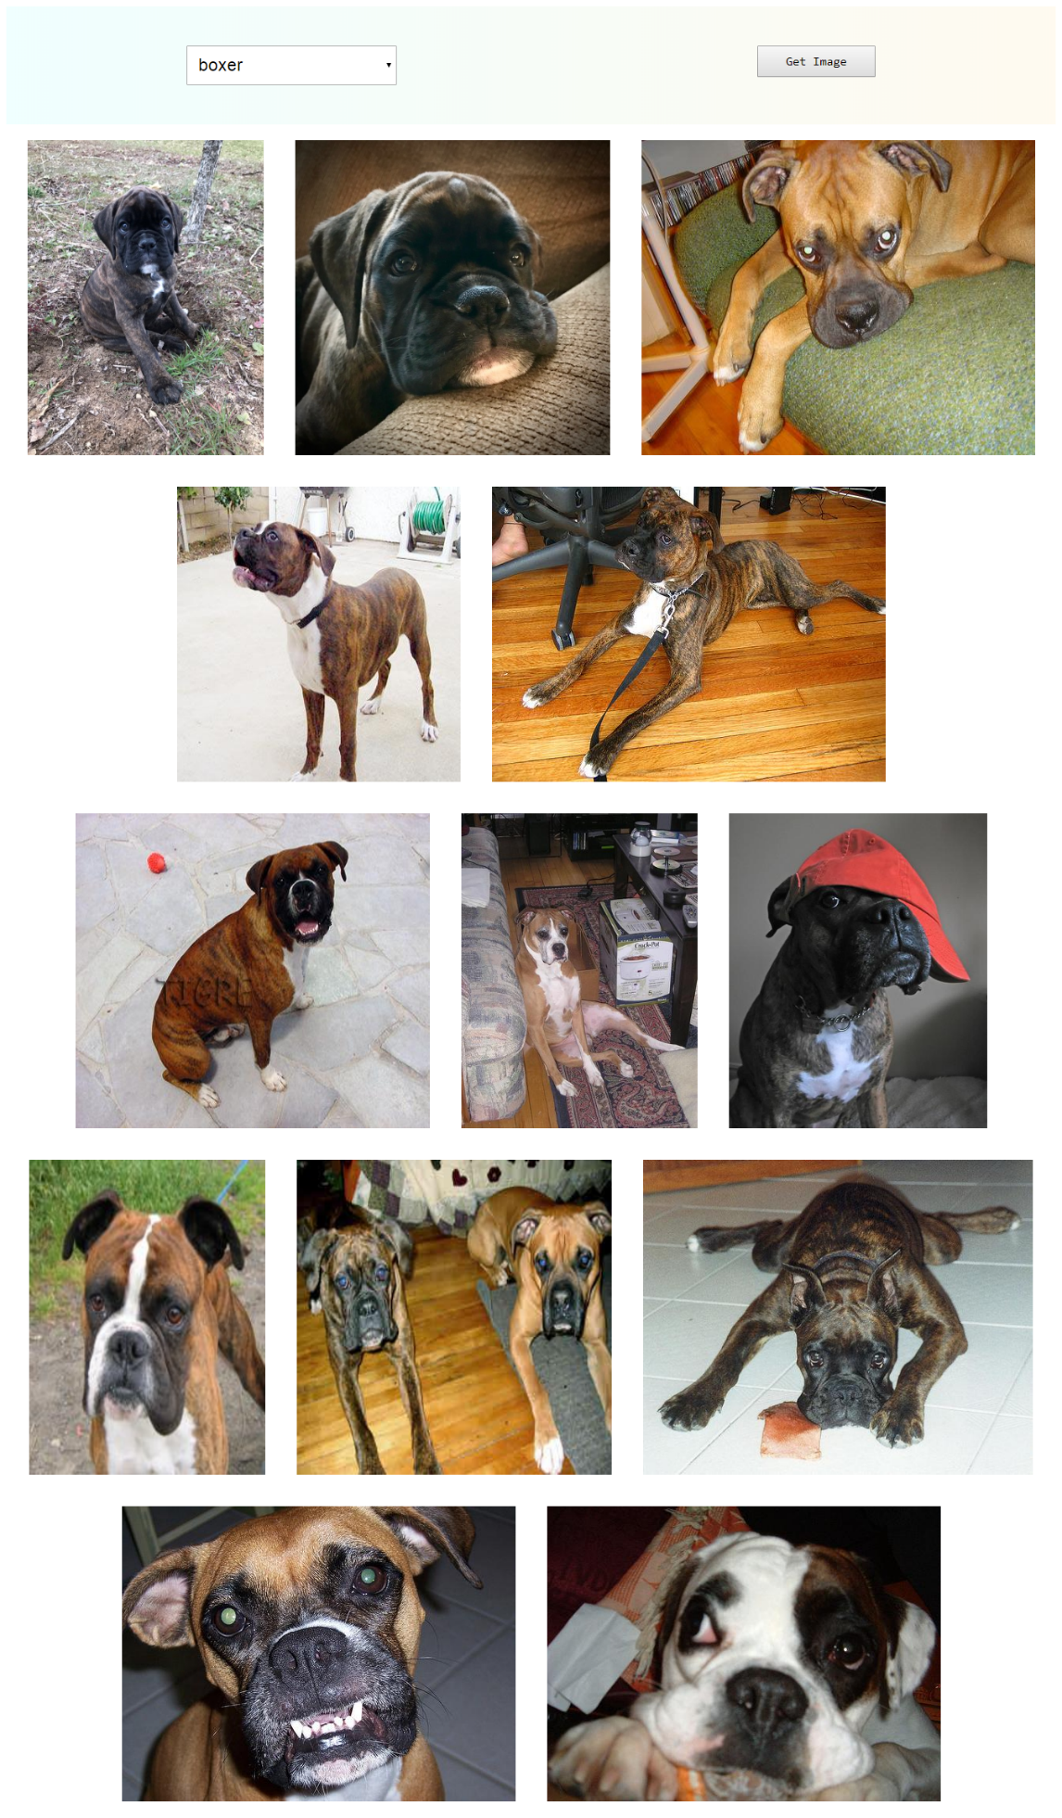](https://ninjasfiles.s3.amazonaws.com/0000000000002037.png)

**When a breed has sub-breed, then the web page looks like this -**

[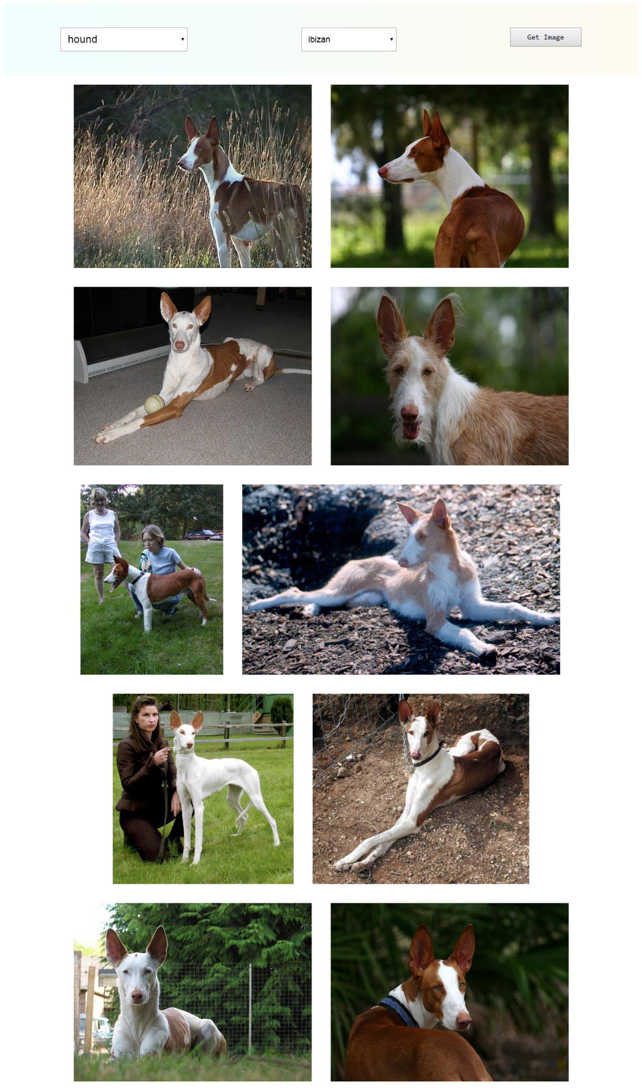](https://ninjasfiles.s3.amazonaws.com/0000000000002038.png)